1. Hacker Language - > LEET SPEAK 1337

Encode ‘Steven McKinen’ with LEET SPEAK 1337 and we get ‘573V3N MCK1N3N’

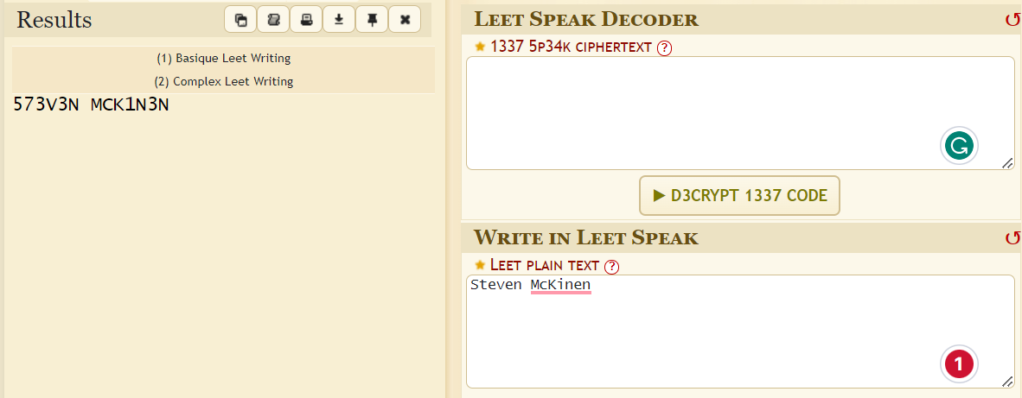

1. Search for ‘573V3N MCK1N3N’ on google and we find a link to his twitter account <https://twitter.com/st1n3n>
2. Search for the twitter archive using way back machine.

* History found: Aug 18, 2021

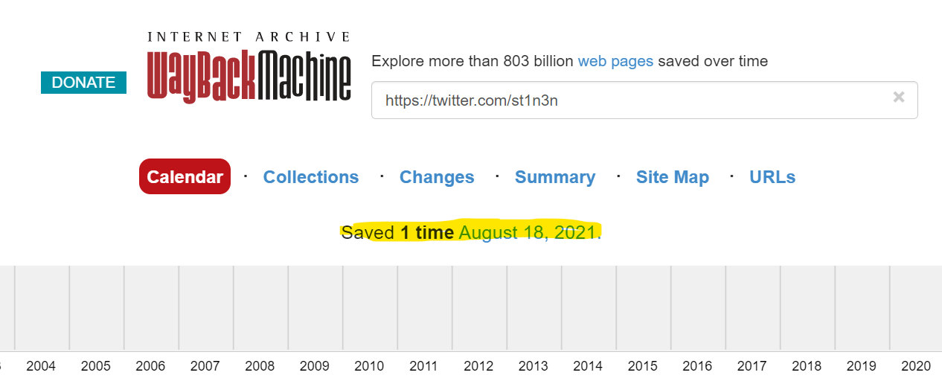

* Everything looks the same except for this tweet that contains random alphanums

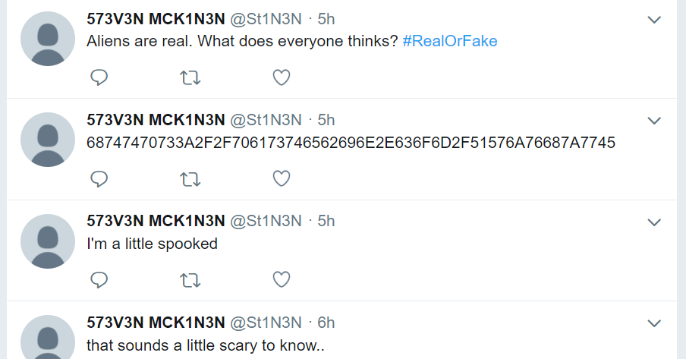

1. Hex to Ascii -> https://pastebin.com/QWjvhzwE

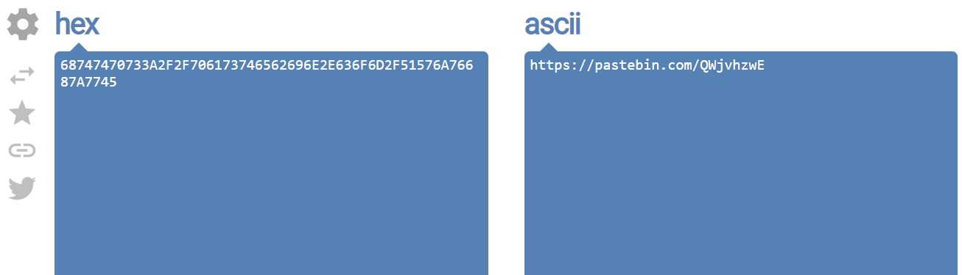

1. Go to the Pastebin link and we see another link posted by a guest

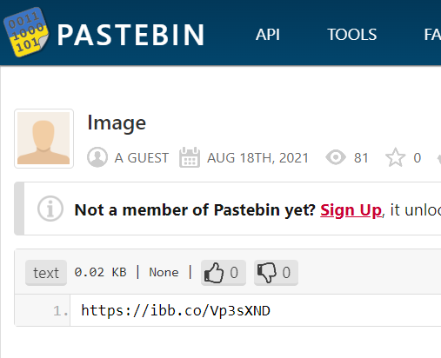

1. Opening the link shows us a JAV Code (a colour two-dimensional matrix symbology whose basic symbols are made of colourful square modules arranged in either square or rectangle grids)

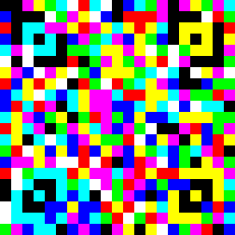

1. Scan the JAB code -> Q1o0MDY3e0cwMGRfdDAtUzNlX1kwdX0=

(used jabcode.org)

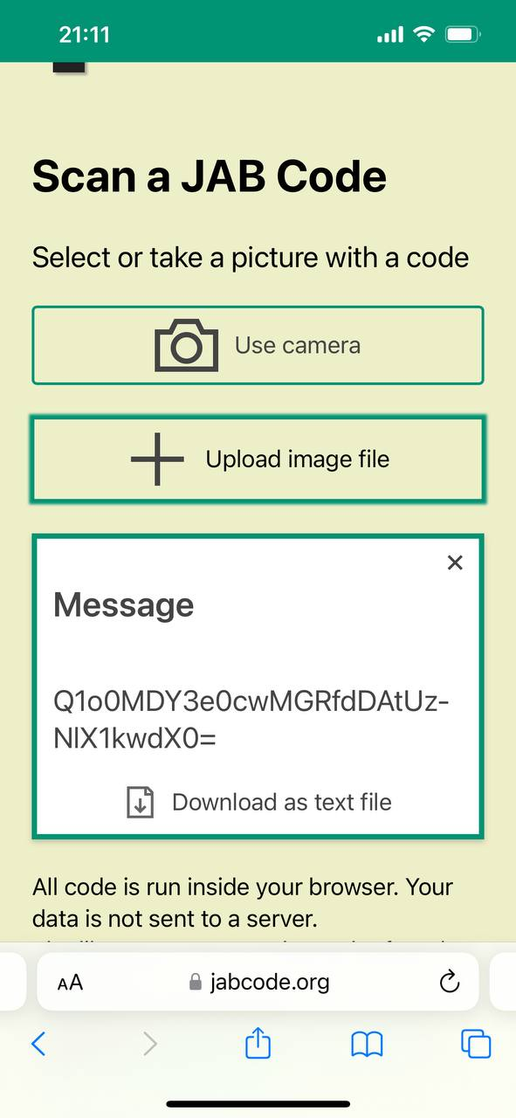

1. Convert the string from base64 to ascii

Flag: CZ4067{G00d_t0-S3e_Y0u}